**Face detection in live video feed**

What is face detection?

Face detection also called facial detection is an artificial intelligence (AI) based computer technology used to find and identify human faces in digital images.

Face detection technology can be applied to various fields including security, biometrics, law enforcement, entertainment, and personal safety to provide surveillance and tracking of people in real-time.

In face analysis, face detection helps identify which parts of an image or video should be focused on to determine age, gender, and emotions using facial expressions.

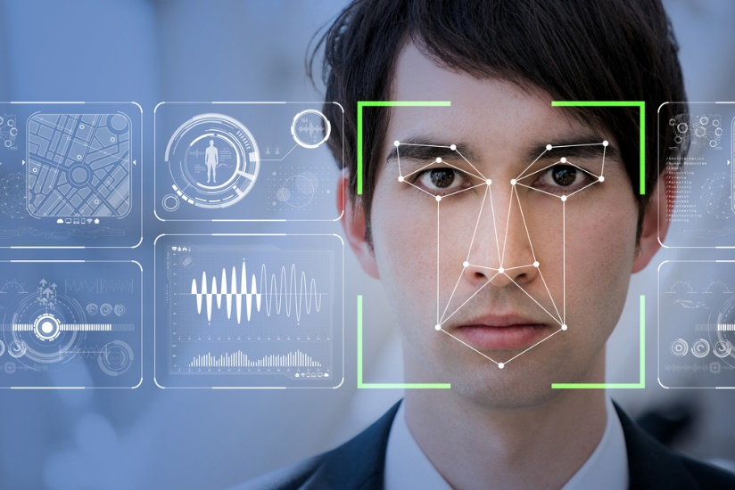

### How does face detection work?

Face detection applications use algorithms and ML to find human faces within larger images, which often incorporate other non-face objects such as landscapes, buildings, and other human body parts like feet or hands.

* Face detection algorithms typically start by searching for human eyes one of the easiest features to detect.
* The algorithm might then attempt to detect eyebrows, the mouth, nose, nostrils, and the iris.
* Once the algorithm concludes that it has found a facial region, it applies additional tests to confirm that it has, in fact, detected a face.

**Methods**

The methods used in face detection can be :-

* **Knowledge-based or rule-based methods** -- escribe a face based on rules. The challenge of this approach is the difficulty of coming up with well-defined rules.
* **Feature invariant methods --** which use features such as a person's eyes or nose to detect a face -- can be negatively affected by noise and light.
* **Template-matching methods --** are based on comparing images with standard face patterns or features that have been stored previously and correlating the two to detect a face. Unfortunately, these methods do not address variations in pose, scale, and shape.
* **Appearance-based methods --** employ statistical analysis and machine learning to find the relevant characteristics of face images. This method, also used in feature extraction for face recognition, is divided into sub-methods.

Face detection algorithm

One of the popular algorithms that use a feature-based approach is the Viola-Jones algorithm.

**Viola-Jones algorithm :-**

* Viola-Jones algorithm is named after two computer vision researchers who proposed the method in 2001, Paul Viola and Michael Jones in their paper, “Rapid Object Detection using a Boosted Cascade of Simple Features”.
* This algorithm is painfully slow to train but can detect faces in real-time with impressive speed.

**The Viola-Jones algorithm has four main steps:-**

1. **Selecting Haar-like features**

A simple way to find out which region is lighter or darker is, to sum up, the pixel values of both regions and compare them. The sum of pixel values in the darker region will be smaller than the sum of pixels in the lighter region. If one side is lighter than the other, it may be an edge of an eyebrow or sometimes the middle portion may be shinier than the surrounding boxes, which can be interpreted as a nose. This can be accomplished using Haar-like features and with the help of them, we can interpret the different parts of a face.

There are 3 types of Haar-like features that Viola and Jones identified in their research:

* Edge features
* Line-features
* Four-sided features

Edge features and Line features are useful for detecting edges and lines respectively. The four-sided features are used for finding diagonal features.

The value of the feature is calculated as a single number: the sum of pixel values in the black area minus the sum of pixel values in the white area. The value is zero for a plain surface in which all the pixels have the same value, and thus, provide no useful information.

Since our faces are of complex shapes with darker and brighter spots, a Haar-like feature gives you a large number when the areas in the black and white rectangles are very different. Using this value, we get a piece of valid information out of the image.

1. **Creating an integral image**

While selecting the haar-like features we perform computation on all the pixels involved in identifying a particular feature. These calculations can be very extensive in the case of large features. The integral image plays its part in allowing us to perform these intensive calculations quickly so we can understand whether a feature of several features fits the criteria.

An integral image (also known as a summed-area table) is the name of both a data structure and an algorithm used to obtain this data structure. It is used as a quick and efficient way to calculate the sum of pixel values in an image or rectangular part of an image.

1. **Running AdaBoost training**

The number of features that are present in the detector window is large, but only a few of these features are important to identify a face. So we use the AdaBoost algorithm to identify the best features.

In the Viola-Jones algorithm, each Haar-like feature represents a weak learner. To decide the type and size of a feature that goes into the final classifier, AdaBoost checks the performance of all classifiers that you supply to it.

To calculate the performance of a classifier, you evaluate it on all subregions of all the images used for training. Some subregions will produce a strong response in the classifier. Those will be classified as positives, meaning the classifier thinks it contains a human face. In the classifier's opinion, subregions that don’t provide a strong response don’t contain a human face. They will be classified as negatives.

The classifiers that performed well are given higher importance or weight. The final result is a strong classifier, also called a BOOSTED CLASSIFIER, that contains the best performing weak classifiers.

1. **Creating classifier cascades**

The models are then organized into a hierarchy of increasing complexity, called a “cascade“.We have a 24×24 window, which we slide over the input image, and we need to find if any of those regions contain the face. The job of the cascade is to quickly discard non-faces, and avoid wasting precious time and computations. Thus, achieving the speed necessary for real-time face detection.

We set up a cascaded system in which we divide the process of identifying a face into multiple stages.

In the first stage, we have a classifier that is made up of our best features, in other words, in the first stage, the subregion passes through the best features such as the feature which identifies the nose bridge or the one that identifies the eyes.

In the next stages, we have all the remaining features:-

* Face recognition

Face detection and Face Recognition are often used interchangeably but these are quite different. Face detection is just part of Face Recognition.

Face recognition is a method of identifying or verifying the identity of an individual using their face.

* Live Feed Face Detection

Videos are made up of frames, which are still images. We perform face detection for each frame in a video. We capture a frame from the live video feed and perform the detection. So when it comes to detecting a face in a still image and detecting a face in a real-time video stream, there is not much difference between them.

**Advantages of Face Detection:**

As a key element in facial imaging applications, such as facial recognition and face analysis, face detection creates various advantages for users, including:-

* **Improved security --** Face detection improves surveillance efforts and helps track down criminals and terrorists. Personal security is also enhanced since there is nothing for hackers to steal or change, such as passwords.
* **Easy to integrate --** Face detection and facial recognition technology is easy to integrate, and most solutions are compatible with the majority of security software.
* **Automated identification --** Face detection allows the identification process to be automated, thus saving time and increasing accuracy.